A Brief Introduction

My name is Preecha Saetaew, or known by my nickname as Giant. I;m currently 18 years old, and this is my first year here at Chulalongkorn University. My home province is Chiang Mai, where I live with my parents and my little brother. Prior to studying at Chulalongkorn University, I used to study at Monfort College Primary Section and Unity Concord International School, the latter where I acquired my High School Diploma and paved the way for me to study here at Chulalongkorn University.

My key intentions to study and pursue a degree with PGS is that I want to better understand how society and governments works, as well as the relations between civilian social life, the government and the international stage. I firmly believe that pursuing a PGS degree will not only make me achieve these goals but to also pursue a successful career in the related fields, such as being a politician, diplomat or the civil service, some of which are careers in which I aspire to become. The reason that politics is one of the subjects that I am most interested in also fueled my aspirations to pursue a degree with PGS.

Furthermore, I also have experience from extracurricular activities I took part in during my time in secondary school, such as Interact Club (Part of the Rotary International) and Model United Nations. These activities not only helped deepen interest in the related fields, but also gave me various new knowledge, such as how international organisations work and how countries interact with each other on the global stage.

I’m looking forward to continuing my studies here at Chulalongkorn University and pursuing a degree with PGS.

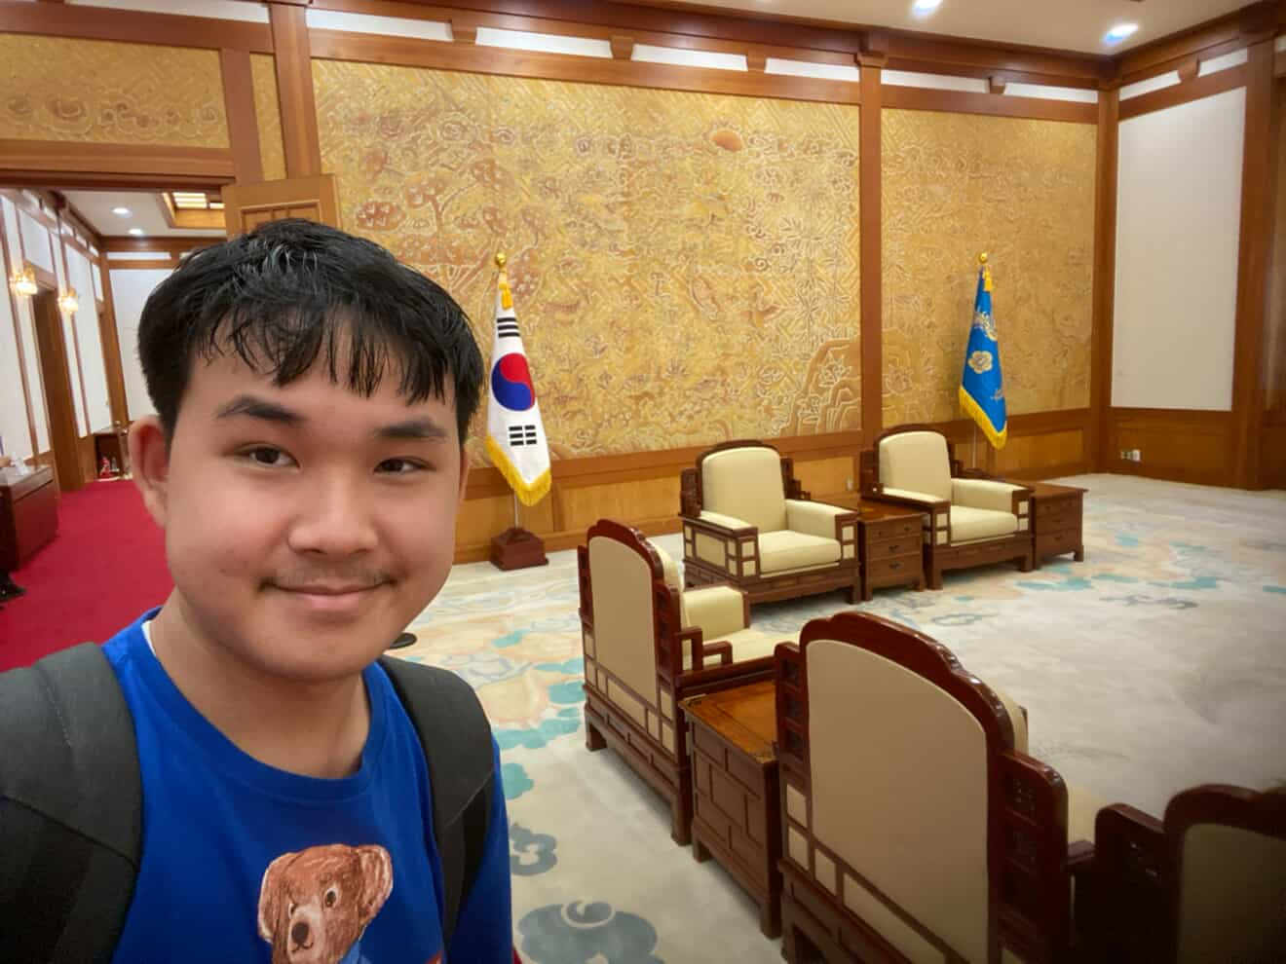

A photo of me

Location: Residence of the President of South Korea (Blue House)